Local child poverty indicators 2018/19 – distribution and trends

Professor D. Hirsch, Centre for Research in Social Policy, Loughborough University, May 2020.

- Introduction

In March 2020, the DWP and HMRC produced an important new set of local indicators of child poverty. Up until now, estimates of local child poverty rates have not been able to draw on direct calculations of incomes at local area level. The previous HMRC series on children in low income families drew partially on tax credit information for working families, but produced an account of child poverty in working and non-working families that corresponded poorly with more direct survey evidence. In contrast, the new indicators look directly at most of the income sources reported for tax, tax credit and benefit purposes for individual families. Unlike surveys, they cover the whole population not just a sample, and can therefore be considered at the very local level. Since these advantages create a stronger basis for estimating local child poverty than previously available, it can be considered superior to the previous modelled estimates prepared for End Child Poverty, and should be the starting point for any future indicators.

The basis for the new method is summarised in the appendix below. This paper and accompanying tables take a first look at the results. More detailed analysis will follow later in 2020, subject to data access related to the Covid-19 shutdown. For the purposes of this initial summary, the following four important aspects of the current results should be noted.

- AHC or BHC? The dataset is based on a ‘before housing cost’ (BHC) estimate of relative poverty (specifically, the percentage of children living in households below 60% median equivalised income). This measure takes no account of the effect on disposable income of some households having to pay a lot more in rent or mortgage payments than others. This is because unlike in a survey, the information collected by the benefits and tax authorities does not systematically include people’s housing costs. For this reason, comparison of the overall levels of child poverty shown in different parts of the country using this measure need to be treated with caution. In our subsequent analysis, we plan to estimate the ‘after housing cost’ (AHC) child poverty rates by area, drawing on survey data of the relationship between average local housing costs and the difference between the AHC and BHC rates.

- Change over time: While the currently available data thus have limited value in identifying the areas where the effects of child poverty are most severe, they provide useful information on the change in individual areas over time. Covering a four-year period from 2014/15 to 2018/19, it provides for the first time a consistent basis for looking at local change based directly on the measurement of families’ incomes. During a period when child poverty has been rising, this gives an indication of which local authorities and parliamentary constituencies it has done so fastest.

- Limits to measuring changes: Despite this new opportunity to measure change over time, we must still be cautious about interpreting such change at the most local levels. The figures use mid-year population estimates to calculate percentage rates. These estimates, which are not based on direct data collection in between censuses, do not immediately reflect changes that can have significant effects on the child population at ward level or below - such as the building of new homes or the rise or fall of the concentration of families with children in an area. For this reason, we only show change at local authority and parliamentary constituency levels.

- Tracking the distribution: While changes in child poverty rates in some individual wards are likely to be accurate, ward-level data can show useful information about trends in the overall distribution of child poverty. An important reason for tracking local poverty data is to monitor whether the overall concentration of child poverty is changing. Is the problem becoming more or less concentrated across the country? Overall measures of spatial inequalities can show this, regardless of which specific areas are seeing the greatest changes. Like measures of income inequality such as the Gini coefficient, they tell us whether we are becoming more or less equal as a society.

- Local authority and parliamentary constituency rates, 2014/15 to 2018/19

Data tables 1 and 2 show, for each local authority and parliamentary constituency in Great Britain, the estimated percentage of children under the age of 16 who live in households with below 60% of median income BHC. (The series is not available for Northern Ireland).

Because these tables are only able to look at child poverty before housing costs, they underestimate the relative importance of child poverty in London, because they do not take account of the effect of high housing costs on family living standards there. In the 2019 ECP indictors based on modelled child poverty rates, four of the top six parliamentary constituencies and all of the top four local authorities with the highest AHC poverty rates were in London, but this was true of only one constituency and one local authority in the top 20 when measured BHC. Similarly, in the present figures, child poverty (BHC) figures, all the areas with the highest rates are in conurbations in the Midlands, Northern England and Scotland and none in London.

Nevertheless, the data over time allows us to observe in which areas child poverty has increased the fastest since the mid-2010s, a period in which relative child poverty has been rising, both before and after housing costs. Using a BHC indicator to monitor such change is likely to produce similar results to an AHC indicator, given that the relative level of housing costs in different parts of the country changed less between 2014/15 and 2018/19 than in the previous four year period. For example, the ONS’s index of private rents shows average increases in both London and the rest of the country of around 7.5% over the later period, whereas in the four previous years it had been 16% in London compared to 6% in the rest of the country.

In this context, it is significant that the greatest local increases in child poverty rates on the new measure came almost entirely in parliamentary constituencies located in the conurbations of the Midlands and North of England, as shown in Data Table 3, with the top 20 increases shown below in Table A. Table B shows significant differences in regions overall, with child poverty rising fastest, by 6.5 percentage points, in the North East, but in contrast falling by 1.6 percentage points in the South West.

Table A The 20 parliamentary constituencies with the greatest increase in child poverty, 2014/15 to 2018/19

 | Child poverty rate
Constituency | 2014/15 | 2018/19 | %age point increase
GB | 15.6% | 18.4% | 2.8%
Middlesbrough | 26.7% | 42.4% | 15.6%
Glasgow Central | 30.6% | 42.2% | 11.6%
Newcastle upon Tyne Central | 25.8% | 37.1% | 11.4%
Oldham East and Saddleworth | 26.3% | 36.8% | 10.5%
Bolton South East | 30.0% | 40.0% | 10.0%
Birmingham, Hodge Hill | 38.8% | 48.7% | 9.9%
Birmingham, Ladywood | 36.2% | 46.0% | 9.8%
Leeds East | 25.2% | 34.4% | 9.2%
Liverpool, Wavertree | 20.5% | 29.4% | 8.9%
Oldham West and Royton | 33.0% | 41.9% | 8.9%
Pendle | 28.6% | 37.4% | 8.8%
South Shields | 20.5% | 29.1% | 8.6%
Birmingham, Yardley | 26.9% | 35.1% | 8.2%
Blackburn | 32.7% | 40.7% | 7.9%
Leeds Central | 26.9% | 34.7% | 7.9%
Warley | 27.7% | 35.3% | 7.7%
Manchester, Gorton | 32.1% | 39.5% | 7.4%
Ipswich | 18.2% | 25.6% | 7.3%
Birmingham, Hall Green | 33.5% | 40.7% | 7.3%
Bishop Auckland | 17.5% | 24.7% | 7.2%

Table B Change in child poverty by region, 2014/15 to 2018/19
 | Child poverty rate
Region | 2014/15 | 2018/19 | %age point increase
NORTH EAST | 17.3% | 23.7% | 6.5%
WEST MIDLANDS | 19.1% | 23.8% | 4.7%
NORTH WEST | 18.5% | 23.0% | 4.5%
YORKSHIRE AND HUMBERSIDE | 19.2% | 23.4% | 4.2%
SCOTLAND | 14.5% | 18.1% | 3.6%
LONDON | 14.2% | 17.5% | 3.4%
SOUTH EAST | 10.8% | 13.7% | 2.9%
EAST | 13.1% | 15.4% | 2.2%
EAST MIDLANDS | 16.6% | 16.6% | 0.0%
WALES | 18.4% | 18.1% | -0.2%
SOUTH WEST | 15.0% | 13.5% | -1.6%

Regional tables show a breakdown of local authorities within each region according to how much child poverty has changed. This demonstrates how in some regions, a more rapid increase in child poverty is the norm across most local authorities, while in others, none have increased substantially. However, the extent of this clustering of results by region may have been somewhat exaggerated by the methodology, which calibrates results against regional averages, so these rates of increase are best described as estimates rather than precise calculations.
A further significant aspect of the change in child poverty in recent years has been the increasing proportion of those affected with at least one parent in work. Two thirds were in this situation in 2018/19, an increase of four percentage points over the previous four years. As shown in Data Table 3, in some parts of the country this is as high as 80%. The table also shows where the increase in this phenomenon has been greatest – in particular in London, where many people are working in insecure or variable hour jobs. Strikingly, Table C below shows that almost all of the largest increases in this percentage have been in London constituencies.
Table C The top 20 constituencies by increase in the % of children in poverty with at least one parent working, 2014/15-2018/19

 | % of children in poverty who are in working families
Constituency | 2014/15 | 2018/19 | %age point increase
GB | 63.6% | 67.4% | 3.8%
Putney | 60.2% | 75.7% | 15.5%
Kensington | 53.2% | 67.3% | 14.1%
Westminster North | 54.2% | 68.2% | 14.0%
Islington North | 56.5% | 70.3% | 13.8%
Manchester Central | 50.0% | 63.8% | 13.8%
Tooting | 58.6% | 72.1% | 13.6%
Vauxhall | 57.2% | 70.5% | 13.3%
Hackney South and Shoreditch | 54.8% | 68.0% | 13.3%
Battersea | 53.0% | 66.0% | 13.0%
Brent Central | 62.3% | 75.0% | 12.6%
Newport East | 55.1% | 67.5% | 12.4%
Cities of London and Westminster | 58.0% | 70.3% | 12.3%
Holborn and St Pancras | 60.4% | 72.6% | 12.1%
Hayes and Harlington | 65.7% | 77.6% | 12.0%
Poplar and Limehouse | 66.7% | 78.6% | 12.0%
Bexleyheath and Crayford | 62.1% | 74.0% | 11.9%
Hendon | 69.0% | 80.8% | 11.8%
Hammersmith | 58.1% | 69.8% | 11.7%
Aberavon | 46.2% | 57.8% | 11.6%
Finchley and Golders Green | 65.6% | 77.1% | 11.5%

- The distribution of child poverty across wards

To what extent is child poverty concentrated in the most deprived areas of the country, as opposed to spread relatively evenly across areas? Any changes in this distribution over time is an indication of how inequalities in life chances based on geography are evolving. The local data produced for the first time in 2020 give an opportunity to consider such changes.

Figure 1 shows that if the country’s children are divided in to ten equally-sized groups, classified by the percentage of children in poverty in the ward where they live, over six times as many are in poverty in the most deprived than in the least-deprived group. However, the diagram also shows that this concentration has got neither better nor worse, despite the general increase in poverty. The proportionate distribution of children among the ten groups is almost identical to four years previously. This suggests that child poverty is deteriorating across better and worse off areas of the country in proportion to its previous levels.

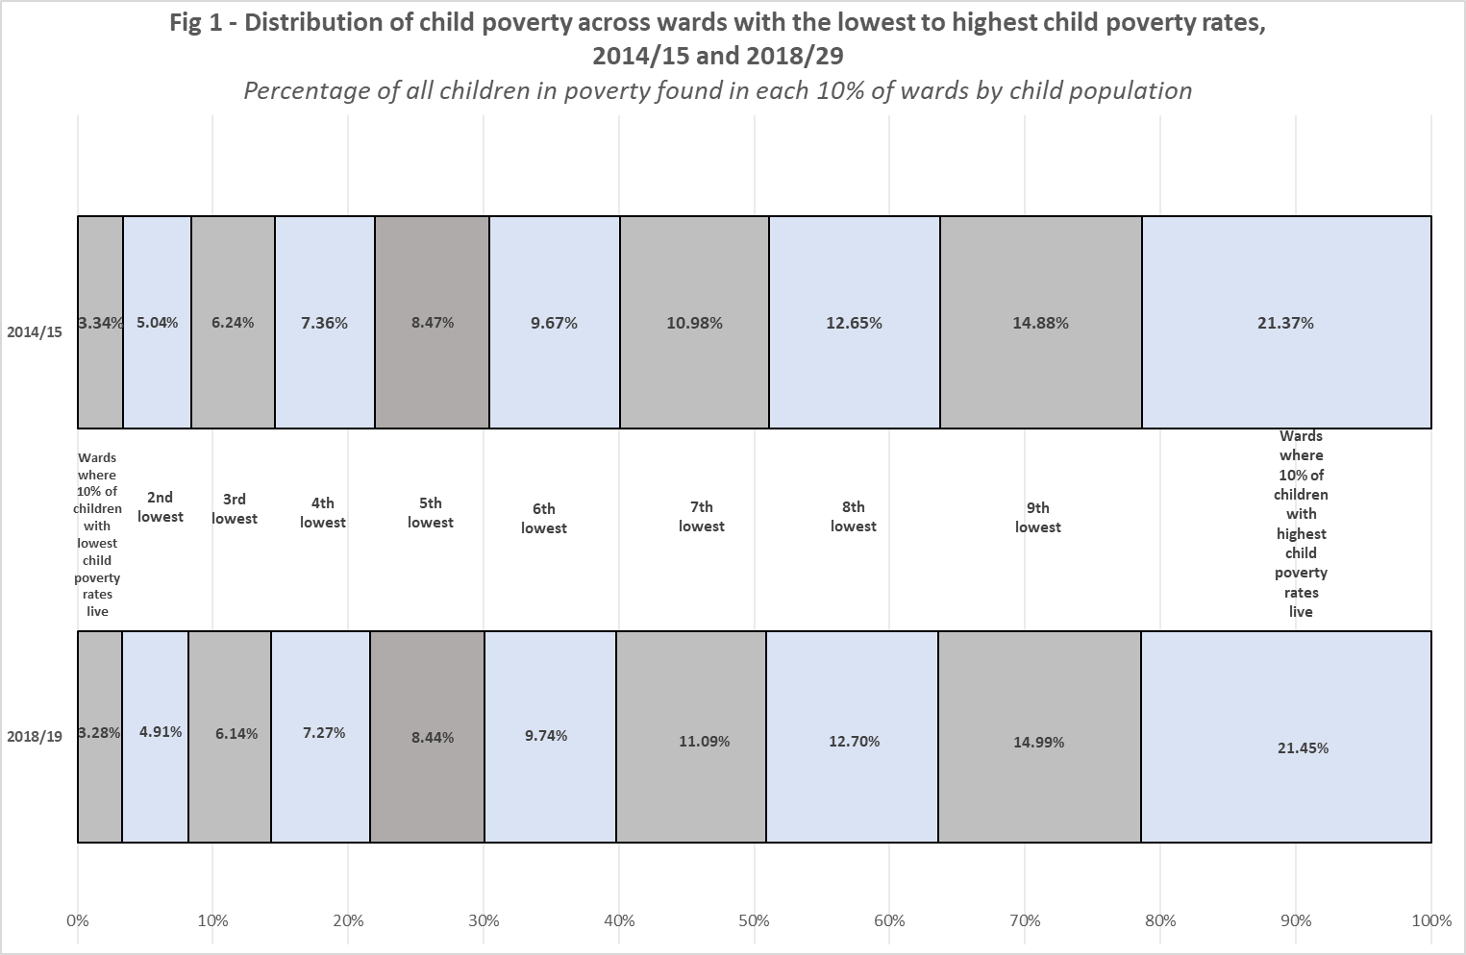

Nevertheless, this does not mean that the deterioration is equally damaging everywhere. A proportionate increase means that areas starting off with a high rate will see more additional children in poverty than one starting off with a low rate. This is illustrated in Figure 2. At the 10th percentile – the ward with a child poverty rate higher than in the best-off wards where 10% of children live, the increase was from nearly 7% to nearly 8%, meaning one extra child in poverty for every hundred children living there. At the 90th percentile, it was from 26% to 30%, so an additional child in poverty for every 25 children, and at the 99th percentile, this rises to one in every ten.

These results show that even when relative concentrations of poverty do not increase, a rising child poverty rate hits children in more deprived areas harder. In particular, as shown above, children in some deprived areas of England’s metropolitan areas outside London have become far more likely to be living in families below the poverty line. The figures reviewed in this paper are shining a spotlight on such changes, showing how the chances of children in some areas have deteriorated to a greater extent than shown by the creeping up of the national child poverty rate.

Figure 2 Child poverty rates across wards, 2014/15 and 2018/19
% in poverty by each percentile of child population, ranked by ward CP rates
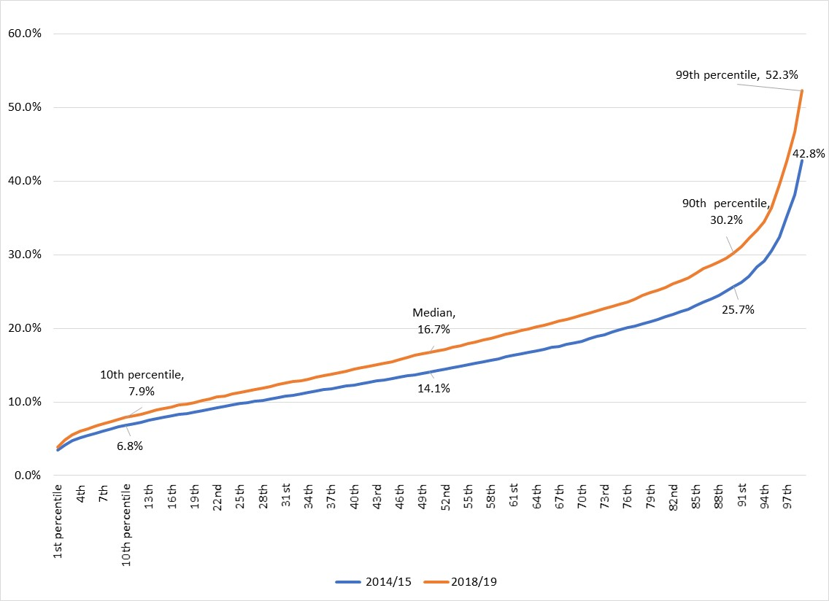

Appendix Summary of method for deriving the new local child poverty indicator

The local child poverty estimates compiled by DWP/HMRC are based on family income data.

A ‘family’ is defined as a single person or couple plus any dependent children.

This is not the same as a ‘household’, which also includes people living together and sharing some costs and/or living space, who are not in the same family.

In these data, the income of all families is considered using tax, tax credit and benefit data.

(This is not as complete an account of income as in household income surveys since it excludes some kinds of income such as investment income. However, it gives a consistently defined income estimate based on the whole population not just on a sample as in the surveys, making local area calculations possible.)

Even though the estimates are based on family income, they seek to make an estimate of household poverty, consistent with the Households Below Average Income measure.

They do this by setting the results alongside the household rates of child poverty in the HBAI survey, broken down by region and work status.

In each region, the percentage of children in household poverty before housing costs is observed from HBAI, both for those living in families where at least one parent works and those in non-working families.

In each case, those same percentage poverty rates are assumed to apply to the family income results collected by DWP and HMRC.

For example, if 10% children in working families in Region A. are in household poverty according to HBAI, the 10% of children in working families in that region with the lowest reported family incomes are also assumed to be in poverty.

By observing in which areas within the region those 10% of children live, and by repeating this for children in non-working families, the number and hence percentage of children in each local area estimated to be in household poverty is derived.

Unlike other child poverty data, which covers children up to the end of secondary school, these estimates are only for children under the age of 16. This is because in order to derive percentage rates, population data by age (mid-year estimates) have been used. Conventionally, a 'child' over the age of 16 is one who is still in full-time secondary education, so not all 16-19 year olds are considered. The previous means of identifying the child population, Child Benefit, is no longer usable because the exclusion of some well-off families from eligibility has made it an incomplete count.

The mid-year estimates do include information on internal migration, based mainly on GP registrations, but this is unlikely to give a full account of changes in population composition (for example, because people don’t necessarily register with a GP immediately on moving, if at all).

