**Local indicators of child poverty after housing costs, 2018/19**

Summary of estimates of child poverty after housing costs in local authorities and parliamentary constituencies, 2014/15 – 2018/19

Donald Hirsch and Juliet Stone

October 2020

**Contents**

1. Introduction 3

2. Methods 3

3. Local authority and parliamentary constituency rates in 2018/19 4

4. Change in local child poverty rates between 2014/15 and 2018/19 6

5. The effect of housing costs 9

6. Appendix A: Summary of DWP/HMRC method for deriving the new local child poverty indicator 12

7. Appendix B: Method used by Centre for Research in Social Policy adjust DWP/HMRC’s local area data on children in low income families to account for housing costs 13

# Introduction

In March 2020, the DWP and HMRC produced an important new set of local indicators of child poverty. These provide the most reliable indicator of local child poverty to date, but have one major limitation. They estimate the percentage of children living in households with below 60% median income, but look at this only on a ‘before housing costs’ (BHC) basis. That is to say, they take no account of the fact that comparing incomes for households in different parts of the country where housing costs vary does not produce a like for like comparison of disposable incomes. As a result, the figures greatly understate the impact of low income in areas such as London with high housing costs.

This paper and accompanying data use the DWP/HMRC local indicators combined with information about housing costs at the local level to estimate poverty rates after housing costs (AHC) - i.e. how many are children are in households with incomes net of housing costs that are below 60% of the median. It makes estimates local authorities and parliamentary constituencies for each of five years from 2014/15 to 2018/19. Note that the total number of children in poverty shown here only includes those aged under 16, and is therefore lower than in the main poverty statistics, which also includes 16-19 year olds in full-time secondary education.

# Methods

Before 2020, estimates of local child poverty rates in the UK had not been able to draw on direct calculations of incomes at local area level. Household income surveys do not have sufficient sample sizes to provide breakdowns for areas smaller than a region. The previous HMRC series on children in low income families drew partially on tax credit information for working families, but produced an account of child poverty in working and non-working families that corresponded poorly with more direct survey evidence. In contrast, the new indicators look directly at most of the income sources reported for tax, tax credit and benefit purposes for individual families. Unlike surveys, they cover the whole population not just a sample, and can therefore be considered at the very local level. The basis for the new method is summarised in the Appendix A below. An earlier paper for End Child Poverty, published in May 2020, summarised these results, based on BHC incomes.

The present figures estimate an AHC data set, building on the BHC data. There is not a way of directly looking at AHC incomes from information held by the tax and benefit authorities, since only some people (notably those claiming Housing Benefit or the rent element of Universal Credit) need to report housing costs. Instead, we modelled the effect of housing costs by area on child poverty rates, by looking at household survey data alongside statistics on private rent levels by local area. Specifically, using the Valuation Office Agency rent data and the Understanding Society survey, we observed the correlation between private rent levels by local authority and the ratio of AHC to BHC poverty rates. This relationship, observed across the country, gave a basis for making an estimate in each local authority of child poverty AHC. For parliamentary constituencies, we made similar estimates, based on the modelled ratio of AHC to BHC poverty rates in the local authority where the constituency (or the largest number of its wards, in constituencies that span more than one local authority) is located. These estimates were further refined using median house prices by parliamentary constituency. (We were however unable to make the adjustments for individual wards, since valid data on housing costs at this local level are unavailable, meaning that the only ward comparisons are [the BHC ones produced by DWP](http://www.endchildpoverty.org.uk/wp-content/uploads/2020/10/local-CP-BHC-2014-15-to-18-19.xlsx)/HMRC.) Appendix B sets out our method in more detail.

# Local authority and parliamentary constituency rates in 2018/19

Tables 1 and 2 show the 20 local authorities and constituencies with the highest child poverty rates, after housing costs, in 2018/19, the latest year for which data are available. Data for all areas, for all years between 2014/15 and 2018/19, can be found [here](http://www.endchildpoverty.org.uk/wp-content/uploads/2020/10/local-child-poverty-estimates-ahc-october-2020-1.xlsx).

**Table 1 The 20 local authorities with highest child poverty rates, 2018/19**

|  |  |
| --- | --- |
| **Local authority** | **% of children below 60% median income after housing costs, 2018/19** |
| **UK** | **30%** |
| Tower Hamlets | 55.4% |
| Newham | 50.3% |
| Barking and Dagenham | 49.9% |
| Hackney | 48.0% |
| Waltham Forest | 47.4% |
| Southwark | 44.3% |
| Islington | 43.4% |
| Greenwich | 43.2% |
| Lambeth | 43.0% |
| Haringey | 42.4% |
| Lewisham | 42.0% |
| Birmingham | 41.6% |
| Redbridge | 41.3% |
| Middlesbrough | 41.1% |
| Brent | 40.8% |
| Hounslow | 40.8% |
| Manchester | 40.6% |
| Sandwell | 40.4% |
| Oldham | 39.9% |
| Luton | 39.8% |

**Table 2 The 20 parliamentary constituencies with highest child poverty rates, 2018/19**

|  |  |
| --- | --- |
| **Constituency** | **% of children below 60% median income after housing costs, 2018/19** |
| **UK** | **30%** |
| Bethnal Green and Bow | 60.6% |
| Birmingham Ladywood | 54.5% |
| Birmingham Hodge Hill | 53.8% |
| West Ham | 52.5% |
| Birmingham Hall Green | 52.5% |
| Poplar and Limehouse | 52.4% |
| Hackney South and Shoreditch | 52.0% |
| East Ham | 51.3% |
| Walthamstow | 50.8% |
| Barking | 50.8% |
| Bermondsey and Old Southwark | 50.3% |
| Tottenham | 50.2% |
| Vauxhall | 49.7% |
| Mitcham and Morden | 48.5% |
| Birmingham Perry Barr | 48.4% |
| Warley | 48.0% |
| Oldham West and Royton | 48.0% |
| Holborn and St Pancras | 47.9% |
| Bradford West | 47.8% |
| Manchester Gorton | 47.6% |

It is immediately noticeable that greatest concentrations of child poverty are in London, once housing costs are taken into account. As shown in Section 5 below, this is a different picture from the BHC estimates produced by the DWP/HMRC, where areas in the conurbations of the Midlands and the North of England feature more prominently. Nevertheless, some of these areas, particularly in Birmingham, show up in the constituency data in Table 2. Thus, it is in Britain’s two biggest cities that the greatest concentrations of child poverty can be seen, influenced in London by high housing costs which leave many families with very low disposable income. In a dozen constituencies in London and Birmingham, the majority of children were below the poverty line in 2018/19, once housing costs are taken into account. These data say nothing about conditions during the coronavirus crisis, but show alarmingly rates of child poverty even before large numbers of people started losing their jobs as a result of the pandemic.

Figure 1 gives the bigger picture on child poverty AHC, showing the rates by country and region. The highest rate is in London, and the lowest in Scotland.

**Figure 1 Percentage of children in poverty, AHC 2018/19, by country and region**

# Change in local child poverty rates between 2014/15 and 2018/19

Tables 3 and 4 show the areas that have seen the greatest growth in child poverty after housing costs during the five years for which data are available. It is noticeable in these tables that virtually all the largest increases have come in the Midlands and Northern conurbations, and none in London. Households in these areas have done relatively badly in terms of their incomes, compared to those in London and elsewhere in the UK. While looking at one point in time, low incomes in these areas are partly counteracted by low housing costs, the greater housing costs paid by Londoners have not increased over the period under observation. Figure 2 shows the index of private rents since 2011. Whereas in the early part of the 2010s, London rents were rising fast compared to elsewhere, between 2015 and 2019, the period covered by these data, the rents rose by the same amount inside and outside London. Thus, the extent to which high rents increase child poverty in the capital has not risen further, and it was the stagnating incomes in other metropolitan areas that drove the greatest increases in child poverty in the second half of the 2010s. Figure 3 shows how this is true at the regional level, with the greatest increase in AHC child poverty coming in the North East, where it rose nine percentage points, while in Wales and South West England it fell slightly.

**Table 3 The 20 local authorities with highest increase in child poverty rates after housing costs, 2014/15 to 2018/19**

|  |  |  |  |
| --- | --- | --- | --- |
| **Constituency** | **% of children below 60% median income AHC** | | |
| 2014/15 | 2018/19 | %age point increase |
| **UK** | **28%** | **30%** | **2%** |
| Middlesbrough | 28.6% | 41.1% | 12.5% |
| Newcastle upon Tyne | 28.2% | 39.2% | 11.0% |
| South Tyneside | 27.0% | 37.3% | 10.3% |
| Hartlepool | 27.5% | 37.3% | 9.8% |
| Sunderland | 27.2% | 36.0% | 8.8% |
| Gateshead | 24.7% | 33.5% | 8.8% |
| Bradford | 29.5% | 38.3% | 8.7% |
| Redcar and Cleveland | 26.4% | 35.1% | 8.7% |
| County Durham | 25.4% | 34.0% | 8.6% |
| Leicester | 29.4% | 37.8% | 8.5% |
| Blackburn with Darwen | 30.9% | 39.1% | 8.2% |
| Darlington | 25.7% | 33.9% | 8.2% |
| Oldham | 31.8% | 39.9% | 8.1% |
| Pendle | 31.0% | 38.8% | 7.8% |
| Northumberland | 24.3% | 32.0% | 7.7% |
| Stockton-on-Tees | 25.3% | 33.0% | 7.7% |
| Nottingham | 29.4% | 37.0% | 7.6% |
| Birmingham | 34.2% | 41.6% | 7.4% |
| North Tyneside | 23.7% | 31.0% | 7.2% |
| Manchester | 33.6% | 40.6% | 7.0% |

**Table 4 The 20 constituencies with highest increase in child poverty rates, 2014/15 to 2018/19**

|  |  |  |  |
| --- | --- | --- | --- |
| Constituency | **% of children below 60% median income AHC** | | |
| 2014/15 | 2018/19 | %age point increase |
| **UK** | **28%** | **30%** | **2%** |
| Middlesbrough | 31.2% | 47.2% | 16.0% |
| Newcastle upon Tyne Central | 31.7% | 45.2% | 13.5% |
| Birmingham Hodge Hill | 40.5% | 53.8% | 13.4% |
| Bradford West | 34.9% | 47.8% | 12.9% |
| Birmingham Ladywood | 41.8% | 54.5% | 12.7% |
| Birmingham Yardley | 32.4% | 44.7% | 12.4% |
| South Shields | 28.2% | 39.3% | 11.1% |
| Bradford East | 36.4% | 46.9% | 10.5% |
| Newcastle upon Tyne East | 27.1% | 36.8% | 9.7% |
| Bolton South East | 37.1% | 46.7% | 9.6% |
| Sedgefield | 23.5% | 33.0% | 9.5% |
| Hartlepool | 27.6% | 37.1% | 9.5% |
| Oldham West and Royton | 38.5% | 48.0% | 9.4% |
| Gateshead | 26.0% | 35.3% | 9.3% |
| Blackburn | 38.1% | 47.3% | 9.2% |
| Jarrow | 23.5% | 32.6% | 9.1% |
| Middlesbrough South and East Cleveland | 24.2% | 33.2% | 9.0% |
| Manchester Gorton | 38.6% | 47.6% | 9.0% |
| North Durham | 24.3% | 33.3% | 9.0% |
| Easington | 25.8% | 34.6% | 8.8% |

**Figure 2 Index of private rents for London and the rest of GB**

**January 2015=100**

**Figure 3 Change in child poverty rate, AHC, 2014/15 to 2018/19, by country and region**

# The effect of housing costs

This report has used the after housing cost indictor of child poverty as the best indicator of how families experience low disposable income. But how much difference has this made in the overall estimates of child poverty, compared to the DWP/HMRC’s before housing cost indicator? This of course varies according to area and the cost of housing. Tables 5 and 6 show in which local authorities and constituencies it makes the most difference. Unsurprisingly, the greatest differences are in London, where housing costs are greatest.

**Table 5 The 20 local authorities with the highest AHC compared to BHC poverty rates, 2018/19**

|  |  |  |  |
| --- | --- | --- | --- |
| **Constituency** | **% of children below 60% median income AHC** | | |
| AHC | BHC | %age point difference |
| **UK** | **30%** | **20%** | **10%** |
| Tower Hamlets | 55.4% | 27.3% | 28.1% |
| Hackney | 48.0% | 21.5% | 26.5% |
| Islington | 43.4% | 18.4% | 25.0% |
| Newham | 50.3% | 25.7% | 24.6% |
| Southwark | 44.3% | 19.8% | 24.5% |
| Lambeth | 43.0% | 18.8% | 24.2% |
| Waltham Forest | 47.4% | 23.2% | 24.2% |
| Camden | 38.9% | 15.3% | 23.6% |
| Barking and Dagenham | 49.9% | 26.3% | 23.6% |
| Haringey | 42.4% | 18.9% | 23.5% |
| Brent | 40.8% | 18.1% | 22.7% |
| Greenwich | 43.2% | 20.6% | 22.6% |
| Lewisham | 42.0% | 19.5% | 22.5% |
| Redbridge | 41.3% | 19.0% | 22.3% |
| Hounslow | 40.8% | 18.7% | 22.1% |
| Ealing | 39.5% | 17.6% | 21.9% |
| Enfield | 39.5% | 17.8% | 21.7% |
| Merton | 37.0% | 16.0% | 21.0% |
| Hammersmith and Fulham | 34.6% | 13.7% | 20.9% |
| Croydon | 38.2% | 17.4% | 20.8% |

**Table 6 The 20 constituencies with the highest AHC compared to BHC poverty rates, 2018/19**

|  |  |  |  |
| --- | --- | --- | --- |
| **Constituency** | **% of children below 60% median income AHC** | | |
| AHC | BHC | %age point difference |
| **UK** | **30%** | **20%** | **10%** |
| Bethnal Green and Bow | 60.6% | 30.1% | 30.5% |
| Hackney South and Shoreditch | 52.0% | 23.9% | 28.1% |
| Bermondsey and Old Southwark | 50.3% | 22.3% | 28.0% |
| Holborn and St Pancras | 47.9% | 19.9% | 28.0% |
| Vauxhall | 49.7% | 22.2% | 27.5% |
| Poplar and Limehouse | 52.4% | 25.1% | 27.3% |
| Islington South and Finsbury | 46.2% | 19.4% | 26.8% |
| West Ham | 52.5% | 25.9% | 26.6% |
| Walthamstow | 50.8% | 24.5% | 26.3% |
| Tottenham | 50.2% | 24.0% | 26.2% |
| East Ham | 51.3% | 25.5% | 25.8% |
| Camberwell and Peckham | 46.1% | 21.1% | 25.0% |
| Hackney North and Stoke Newington | 44.6% | 19.6% | 25.0% |
| Greenwich and Woolwich | 45.9% | 21.0% | 24.9% |
| Mitcham and Morden | 48.5% | 23.8% | 24.7% |
| Leyton and Wanstead | 46.0% | 21.3% | 24.7% |
| Lewisham West and Penge | 45.9% | 21.5% | 24.4% |

While the analysis in this paper has shown that looking at incomes before housing masks high AHC poverty rates in London, it is also important to note that high AHC poverty does not only occur in areas with the highest housing costs. Figure 4 shows, in fact, that the highest rates occur *both* in areas with high housing costs *and* in areas with the lowest housing costs (see explanatory note). The latter comprise areas where both incomes and rents are very low – in particular the poorest areas of Midlands and Northern conurbations. In fact, all five of the local authorities with the highest BHC poverty rates are also among the 20 local authorities with the smallest difference between BHC and AHC rates – ie low-rent areas. These five councils are all in the north of England: Oldham, Pendle, Middlesbrough, Blackburn with Darwen and Bradford. Here, around four in ten children live in households in poverty after housing costs – not as high as in the worst-hit boroughs of London, but still well above the national average.

**Figure 4 Poverty before and after housing costs in local authorities ranked by rent levels**

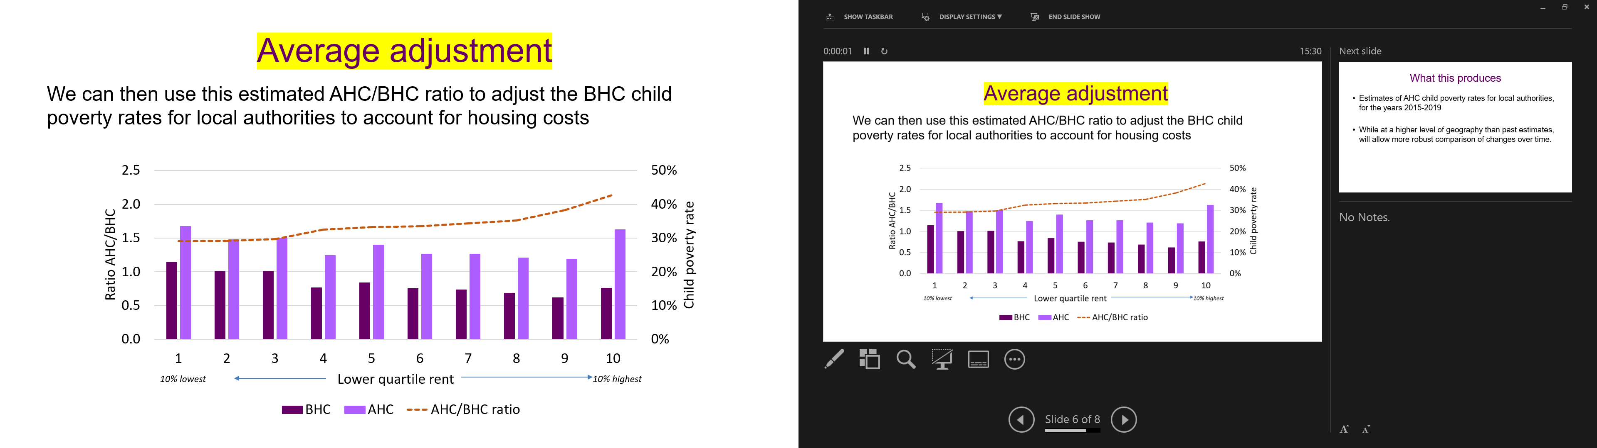

*Explanatory note:*

*This graph divides local authorities into ten groups, with those with the lowest rent on the left, and with the highest rent on the right. The trend line shows the correlation between rent levels on the one hand and the AHC/BHC ratio on the other. Note that in Decile 1, even though low rent levels mean that AHC poverty is not as far above BHC poverty as in other deciles, the fact that BHC poverty is high (because incomes tend to be low-rent areas) means that AHC poverty is also higher than in any other decile except decile 10 where housing costs are the highest.*

# **Appendix A:** Summary of DWP/HMRC method for deriving the new local child poverty indicator

The local child poverty estimates compiled by DWP/HMRC are based on family income data.

A ‘family’ is defined as a single person or couple plus any dependent children. This is not the same as a ‘household’, which also includes people living together and sharing some costs and/or living space, who are not in the same family.

In these data, the income of all families is considered using tax, tax credit and benefit data.

(This is not as complete an account of income as in household income surveys since it excludes some kinds of income such as investment income. However, it gives a consistently defined income estimate based on the whole population not just on a sample as in the surveys, making local area calculations possible.)

Even though the estimates are based on family income, they seek to make an estimate of household poverty, consistent with the Households Below Average Income measure.

They do this by setting the results alongside the household rates of child poverty in the HBAI survey, broken down by region and work status.

In each region, the percentage of children in household poverty before housing costs is observed from HBAI, both for those living in families where at least one parent works and those in non-working families.

In each case, those same percentage poverty rates are assumed to apply to the family income results collected by DWP and HMRC.For example, if 10% children in working families in Region A. are in household poverty according to HBAI, the 10% of children in working families in that region with the lowest reported family incomes are also assumed to be in poverty.

By observing in which areas within the region those 10% of children live, and by repeating this for children in non-working families, the number and hence percentage of children in each local area estimated to be in household poverty is derived.

Unlike other child poverty data, which covers children up to the end of secondary school, these estimates are only for children under the age of 16. This is because in order to derive percentage rates, population data by age (mid-year estimates) have been used. Conventionally, a 'child' over the age of 16 is one who is still in full-time secondary education, so not all 16-19 year olds are considered. The previous means of identifying the child population, Child Benefit, is no longer usable because the exclusion of some well-off families from eligibility has made it an incomplete count.

# Appendix B: Method used by Centre for Research in Social Policy adjust DWP/HMRC’s local area data on children in low income families to account for housing costs

Our estimates have adjusted the official BHC statistics to produce local authority and constituency level estimates of AHC child poverty rates. To produce these estimates we combined household-level survey data with local area data on average private rent levels.

The first step was to calculate AHC and BHC income for each child in Understanding Society, a large UK-wide household survey that includes detailed information on household income as well as information on housing costs. The survey also contains an identifier for the local authority where each member of the sample lives.

We then identified private rent levels in each local authority area, using data from the Valuation Office Agency in England, the Lettings Information Database in Wales, the Rent Service in Scotland and the Northern Ireland Housing Executive in Northern Ireland. While private rents are not the only source of differences in local housing costs, we consider them to be a good indicator, since they account for a greater amount of variation than social rents (whose level are less sensitive to area), and also have a relationship with house prices that helps capture differences in mortgage costs. We tried various indicators of private rent levels, and found that results were very similar regardless of which one we used, so have taken the lower quartile rent for a three bedroom property as an appropriate indicator of a private rent for a low income family with children.

Using these two data sets, we then considered the ratio of AHC to BHC poverty rates for children living in areas with similar rent levels. Specifically, we examined the correlation between private rents by local authority and the AHC/BHC poverty ratio. This produced the following result, showing that in the 10% of local authorities with the highest private rents, AHC poverty relative to BHC poverty tends to be about 50% higher than in those with the lowest rents.

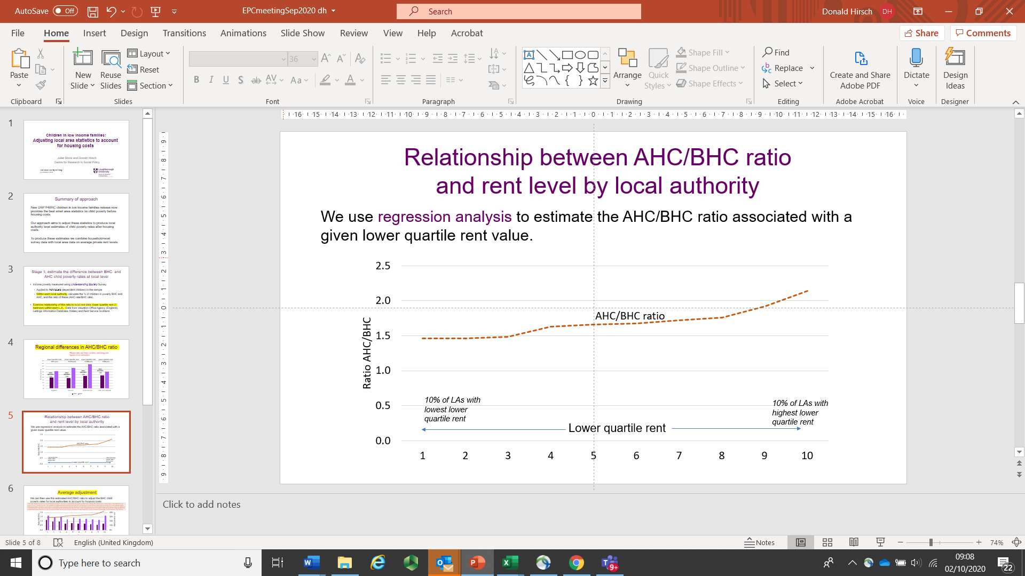

These ratios were applied to the DWP/HMRC data for BHC child poverty rates in individual local authorities, to produce our estimates of AHC estimates. The estimates were then calibrated at regional level to the official estimates of child poverty before housing costs from the DWP Households Below Average Income (HBAI).

The DWP/HMRC data on child poverty are produced only for Great Britain, and not for Northern Ireland. However, the Northern Ireland Statistics Agency (NISRA) produced statistics on child poverty at local government district level as part of the 2017 Northern Ireland Multiple Deprivation Measure (NIMDM). This used administrative data on household income in a very similar way to the new HMRC/DWP data, and the two sources are therefore comparable. We were also able to use 3-year averages of child poverty rates produced by NISRA to estimate the rates for 2014/15 and 2015/16, in addition to the NIMDM data for 2016/17. Unfortunately, no data for Northern Ireland were available for 2017/18 and 2018/19. We therefore used the regional estimates of child poverty before housing costs from HBAI to produce weighted estimates by local authority in Northern Ireland for 2017/18 and 2018/19 based on the local distribution in the previous years. With this in mind, given that the initial source of data on BHC child poverty for Northern Ireland is less robust than the HMRC/DWP data for Great Britain, the estimates should be treated with caution particularly in the most recent years.

We do not have data on local rent levels by Westminster parliamentary constituency, but have used the above ratios for the local authority in which each is situated to make the same transformation from BHC to AHC for the constituency data. Most Westminster parliamentary constituencies are located in an individual local authority, and all but six have the majority of their wards in one local authority, so we have used the rent in that local authority as an estimate of local housing costs. In the six where no local authority contains a majority of wards, we have used data for the local authority containing the greatest number of the constituency’s wards. These cases are all in rural areas, where there are not wide variations in rent levels across the local authorities concerned. We then carried out an additional stage of modelling, where the ratios calculated for local authorities were adjusted based on the median house prices for parliamentary constituencies. Median house prices were derived from the ONS house price statistics for small areas in England and Wales, and the equivalent from Registers for Scotland. This gives a broad picture of local variation in housing costs. Unlike the private rent measure used in the main analysis, houses price data do not account for geographical variation in the distribution of property types. However, the two-stage approach for producing the constituency estimates allowed us to combine, on the one hand, the more precise measure of housing costs (local rents) in geographical areas (local authorities) that only imperfectly approximate the situation at constituency level, and on the other hand a less precise measure of housing costs (median house prices) at a geographical level (constituency) that precisely matches the geography being reported on. This combination helps refine these estimates. (However, in Northern Ireland, we do not have the house price data, so here the estimate draws only on the local authority rent data for housing costs.)

The above process is applied for each of the years in which child poverty is reported, using contemporaneous data on both household income and housing costs in each case.